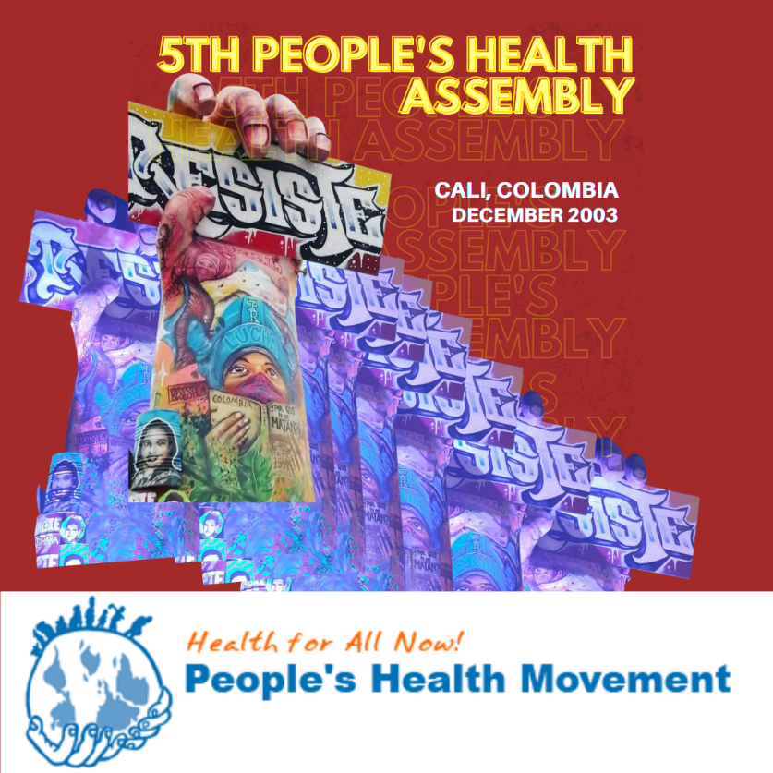

The 5th People's Health Assembly (PHA-5) of the People's Health Movement will take place in Cali, Colombia | December 4-8, 2023.

This is the second time that the PHA will take place in Latin America after PHA-2 was held in Cuenca, Ecuador, in 2005.

The Assembly will be preceded by an International People's Health University in Medellin, Colombia | 27 November – 1 December 2023.

Join us in Cali in December!

Struggling for Health for All
in Post-Pandemic World
Fifth People’s Health Assembly (PHA-5)
Cali, Colombia | 4-8 December 2023
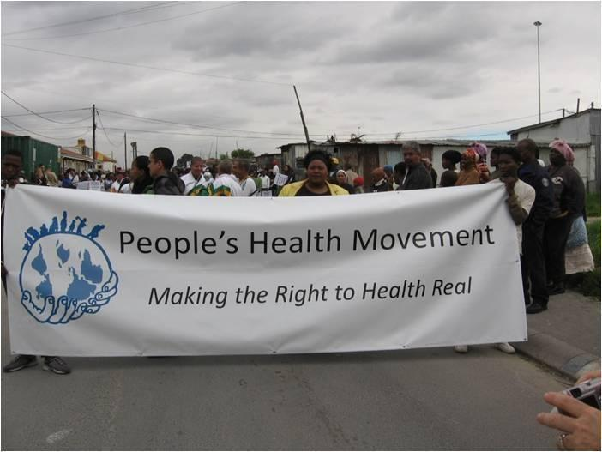

People's Health Movement (PHM)
Website: phmovement.org
Twitter: @PHMglobal
Facebook: @peopleshealthmovement

Table of Contents

I. People's Health Movement (PHM) 4
II. Context of the People's Health Assembly 4
III. Objectives 6
IV. The axes of discussion 7
Axis 1: Towards the transformation of health systems 8
Axis 2: Gender justice in health 10
Axis 3: Ecosystem health: food, energy and climate 11
Axis 4: Resisting forced migration and war 12
Axis 5: Ancestral and popular knowledge and practices 13

People's Health Movement (PHM)
The People's Health Movement (PHM) was founded in 2000 by health activists in response to the failure of countries to achieve Health for All by the year 2000. The vision of PHM is that equity, ecologically sustainable development and peace are the core values for a better world, free from exploitation, discrimination and oppression based on class, gender, race, caste, ethnicity, disability, sexuality, religion, occupation, and immigrant and refugee status; a world in which the human rights, autonomy and health of all communities are respected and promoted. The MOH is committed to comprehensive primary health care and action on the social, environmental, economic and commercial determinants of health through key strategies within the framework of the Health for All Campaign (HFAC) at its core.
The main work of the PSM is based on its organizational components, in particular national circles, regional sections and international networks. Currently, the PSM is present in more than 80 countries, with more than 40 active national circles on six continents, 11 affiliated networks worldwide and many more organizations working at regional and national levels. The PSM supports a range of global and regional activities that integrate the efforts of its national circles and its global and regional networks. Over the past 20 years, the PHM has continued to grow in size, scope and complexity of work, driven by the passion of hundreds of volunteers and a small Secretariat facilitated by a global coordinator. (For more information about the PHM, its governance structure and activities, visit the PHM website: https://phmovement.org/about-3/).

Context of the People's Health Assembly
Important changes in the global context over the past decade that have reworked health struggles include: the threat to comprehensive primary health care; the privatization of health services; the reduction of social assistance; the growing climate crisis; worsening conflict and displacement; the erosion of democratic structures and the positioning of authoritarian-style governments; the rise of right-wing political fundamentalism; the growing power of corporations, while the crisis and inequality and global economic domination deepen; the increase in unemployment; the increase in insecurity and loss of food sovereignty; and the general weakening of international human rights organizations, while at the same time old wars continue and new ones emerge that deepen the dynamics of forced cross-border migration. All this disproportionately affects socio-economically vulnerable groups, especially in countries that have been dominated by colonial rule, in the economic and political periphery, and which are characterized by being low and middle-income countries (LMIC).
Corporations engage in the unbridled destruction of ecosystems and biodiversity, generating enormous volumes of toxic waste while endangering cultural identities and the diversity of life forms. The complexities of conflicts and wars, migration, the climate crisis and threats to democracy - to name but a few - pose new challenges every day. All of these, aided by unjust global and national economic and trade policies, are promoting a capitalist, patriarchal and colonialist development paradigm that is unsustainable and inequitable and creating a complex canvas of deterministic processes that are seriously impeding the realization of health for all. Furthermore, austerity measures in both the South and the North have further compromised access, often as a consequence of the dismantling of public systems and services and the increasing reliance on private health care provision under dynamics of commodification of the right to health.
In the last three years, the world has experienced the most catastrophic health and humanitarian crisis in recent history during the Covid19 pandemic. This crisis is a consequence of the prevailing global civilizational model and makes it urgent to change the cultural, social, political and economic paradigm. The anthropocentric logic that constitutes this model, which is based on the feeling of not belonging to Mother Earth, with the consequent destruction, exclusion, extinction and violence in all its manifestations, demands different ways of thinking and living, education, production, politics, economy and health, present and re-existing in the ancestral wisdom and practices of the peoples themselves.
The pandemic highlighted the long-standing structural processes of health inequalities that exist in a predominantly neoliberal and corporate-controlled world. The great difference was not only limited to the inability of countries with fewer resources to ensure the availability of essential items such as personal protective equipment (PPE), diagnostics, drugs and vaccines, but also to their inability to stand up to the transnational corporations and the big pharmaceutical industry that profited, and continue to do so, in the wake of the pandemic. Many people have died because they did not have access to properly equipped Intensive Care Units, oxygen or even access to basic health services. Hundreds of health care workers have been affected by COVID-19 not only because of the lack of PPE, but also because it deepened the precarious working conditions, the extension of shifts and reduction of rest times, the extremely high emotional burden, the delays in the payment of their salaries, among other conditions.
The abrupt and extremely harsh response, such as the closures, to the Covid-19 pandemic in many countries has exacerbated political deprivation and social and economic inequalities and has precipitated a public health crisis as well as an economic crisis of mammoth proportions. Millions of people around the world have lost their livelihoods and incomes, particularly those who work and subsist in the informal economy. These consequences are disproportionately felt by social groups and individuals at the intersections of caste, race/ethnicity, disability, age, class, gender identity, sexual orientation, occupation, refugees, migrants and other historically marginalized social locations.
Gender-based violence, hunger and starvation, and gender-based work and care overload are among the many problems that have worsened over the past three years. Stigma and violence, including racism against communities, migrants, refugees and patients, are phenomena in the COVID context that have also profoundly affected psychosocial well-being and exacerbated fears and the consequences of inequalities, discrimination and intolerance.
The distressing pandemic period has pushed us to reclaim the moment and to assert social justice, health and human rights through regional and global collaborative and solidarity actions. It is now essential to confront the deep flaws in the organization of our societies and worlds. It is a moment of reckoning, of reevaluating which and whose rights to health are essential and valued, including the rights of nature to which we belong. How to create solidary societies capable of providing access to health services and guaranteeing the right to health, social protection and care, also impacting on those processes that determine the ways of living, getting sick and dying of people and collectives. In this context, in the Fifth People's Health Assembly (PHA) we want to go a step further and go beyond this analysis, placing our struggles for the right to health from solidarity, empathy, equity and respect for biodiversity to safeguard human lives, nature and ecosystems that weave the relationship of life.

Objectives
PHA-5 will
- Analyze the global economic, political and social situation in relation to health policy.
- Recognize and strengthen the diversity of approaches, struggles and resistances for the health of the people.
- Articulate strategies that promote the solidarity of the health movement at the global, regional and local levels.
- Strengthen movements towards health equity, social and gender justice, solidarity and good living, based on the diverse experiences of recent years.
It is expected that the Assembly, through the various discussions, exchanges and collective strategizing, will enhance the capacity of the PHM to organize and mobilize for health and health determinants. It is expected that concrete actions in the main thematic and programmatic areas will emerge from the deliberations of the Assembly. According to what is expressed in the PHM Strategic Plan 2020 - 2025: "The vision of Movement Building is that more governments recognize the Right to Health as a constitutional right, and that PHM contributes to a global movement towards an alternative economic paradigm: more egalitarian, without exploitation, towards Health for All".
The Assembly aims to advance the MOH's goal of health for all through deliberations focused on five thematic axes (discussed below). PHA5 will provide a critical space to deliberate on the specific objectives of each axis.

The axes of discussion
Discussions on each of the thematic axes will allow the PHM to deepen and nuance the understanding of the issues based on the diverse experiences of the participants. Although articulated as discrete thematic axes to allow focused discussions on each of them, these axes are deeply interconnected. These interconnections will also be represented in the meetings to be held during the Assembly. While some of the thematic axes overlap with the current focus of the PSM thematic circles and may inform future strategies and actions of the respective circles, the Assembly, through the thematic axes, will expand the discourse on each of the thematic axes, as well as the interrelationships with each other and with health. The diversity of significant and effective experiences from the multiple participating territories will contribute to the substantive discussion of all the axes.
The analysis of the political economy of health in reflecting on the COVID-19 pandemic has necessitated a debate on two fronts: first, trade rules in relation to intellectual property rights and related issues of access to drugs, diagnostics and vaccines, and second, global health governance. All of the above is framed within a global economic and political model, which subsists and accumulates large profits, thanks to the exploitation, disease and death of all expressions of life.
The COVID-19 pandemic has shown us that the need for radical change in the global intellectual property system is more urgent than ever. While pharmaceutical corporations make huge profits and rich countries stockpile health products, developing countries continue to struggle to test, treat and vaccinate their populations. Millions of people have lost their lives to COVID-19. Transnational corporations (TNCs) took advantage of the opportunities presented by the COVID-19 pandemic, making billions from the production of tests, vaccines and drugs. By prioritizing profit and making billions on the production of tests, vaccines and drugs through unfair trade policy agreements and intellectual property (IP) protection prerogatives, TNCs received favorable positions in policy-making processes, including global health governance. They have been able to infiltrate almost every aspect of people's lives, often in partnership with co-opted international institutions, including through public-private partnerships. At the same time, however, millions of marginalized people/groups lack access to these life-saving products. International trade law, including intellectual property law, perpetuates forms of class, racial and gender discrimination in access to medicines and vaccines, as it reproduces transnational inequalities in access to vaccines, treatments and other COVID-19 technologies.
The TRIPS waiver proposal that was to provide a clear pathway for local and regional production of COVID-19 health technologies has instead resulted in a non-waiver. And this despite the devastation of unequal access and the billions of dollars that Big Pharma has reaped from the pandemic.
These trends include the increasing debt burden of low- and middle-income countries, interpretations of APDIC agreements that undermine equitable access to medical technologies, and pressure from the International Monetary Fund (IMF) on borrowers to implement austerity policies. These processes entrench the commercialization of healthcare and limit the implementation of policies to reduce inequalities between and within countries. It is the duty of the State to improve and guarantee access to medicines to protect, promote and sustain this access and to remove all barriers to accessibility, including patent rights that could interfere with this access.
Understanding the above, PHA 5 will provide the critical space and opportunity to question whether these multilateral structures have become obsolete and whether alternative forms of engagement can be developed within the framework of global political and economic analysis. This analysis will be transversal to each and every one of the axes of discussion proposed below.

Axis 1: Towards the transformation of health systems
The strategy of Primary Health Care built from communities and social and popular organizations has generated multiple models to overcome selective PHC, which lead not only to address inequalities in health care, but also the relationship with all the beings of Nature.
The COVID-19 pandemic has demonstrated the urgent need for countries around the world to implement strategies that promote health systems strengthening and emphasize the need to transform health systems based on the strategy of primary and integrated health care (PHC): service management, use of technology, social participation, governance. Increased funding for the public health sector is a long-standing demand of the health movements.
Comprehensive primary care requires the existence of a new international economic order based on solidarity.
In recent decades, the public health system in many countries has been commercialized and dismantled, often under the guise of Universal Health Coverage (UHC). Austerity measures, combined with an emphasis on "buying" services from the private sector, have undermined public services and compromised equitable access to health care. The vision of a comprehensive model of primary health care, as envisioned in the Declaration of Alma Ata, has been lost along the way. The impact of this was deeply felt during the pandemic, especially among marginalized groups. The breakdown of public health infrastructures pushed people to turn to overpriced private healthcare providers, increasing their out-of-pocket expenses, and families faced insecurity and economic hardship. Even health care workers, including not only frontline health care workers, but also administrative and public health staff, and even cleaning and surveillance staff who were also crucial in the COVID-19 response, were exposed to constant violation of their labor and social rights. Under this premise, it is necessary to build a space for health workers, which allows to highlight the capital-labor contradiction.
Within the capital/labor contradiction, the right to health perspective is closely related to labor rights. For the materialization of the labor rights of health workers, it is necessary to understand the importance of health systems based on primary and integral health care, which manage to position the public good over privatizing interests, and which allow progress in terms of universal access and the formulation and implementation of public policies from a territorial approach. This is because work in decent conditions responds to the organizational dynamics of the structure of the health-disease-care system.
Regarding labor policy, the advance of the capitalist model has led to the generation of violations of different labor rights framed in local and global policies. In this regard, it is necessary to position the guarantee of the principle of labor stability and welfare, which is related to the establishment of the minimum wage by profession or trade, the regulation of the salary curve and scale, the guarantee of financing and payment of payrolls in public hospitals, the regulation of workloads, the protection of professional autonomy, the protection of the medical and health mission, and the guarantee for the quality training of health personnel in decent conditions, among other considerations.
Now, with regard to the gender approach in this approach, there is evidence of a phenomenon of feminization of the workforce within the health sector, which is intrinsically related to caregiving. The evidence of gender inequalities in labor, academic and research scenarios is an example of the necessary progress that needs to be made with gender policies within the sector. Women represent almost 70% of the workforce in the health and social and care services sector worldwide. However, it is estimated that they occupy only about 25% of leadership positions in health (WHO, 2021). As a consequence, policy formulation and sectoral dynamics are highly influenced and determined by patriarchal dynamics, which in turn results in barriers to the recognition and deployment of female talent, ideas and knowledge that cannot be part of decision making. This leadership gap also limits the improvement of health systems.
Global multilateral institutions and the governments of rich countries, influenced by the interests of transnational corporations and the health industry, have been imposing a conception of the transformation of health systems based on the postulates of the CUS. It is an approach to health and health care oriented towards the privatization and commercialization of health systems and the exclusion and elimination of health worldviews and practices that are not adapted to the economic rationalities of profit. The Comprehensive Primary Health Care approach envisions health systems working closely with communities on the social and environmental determinants of health. In contrast, the CUS policy approach focuses on financial protection and explicitly advocates single-payer public financing, but not necessarily through a public provider. It is committed to strengthening health systems and stresses the importance of primary care, but does not address issues of community participation, nor is it critical of the role of private providers, which increase costs or pose an obstacle to equitable access for all.
However, in recent years some positive examples are emerging of governments and communities working to build strong public health systems and incorporating measures on the social determinants of health and investing in health workers. Together with health movements and community organizations, health workers and their unions have been involved in campaigns demanding the reversal of the privatization of public health services and the strengthening of public health systems.
PHA5 provides the critical space and opportunity to
- Learn about organizing strategies for health activists, including health workers, to strengthen public health systems and improve working conditions
- Analyze the consequences of the dominant CUS model in national health systems and histories of its privatization
- Sharing experiences on and lessons from the fight against privatization, community organizing to protect and strengthen public health care and action at the political level that enables comprehensive primary health care, including strategies for social participation in health in the different territories
- Establish mechanisms for joint political advocacy at local, regional and global levels on the situation and demands in terms of labor and social issues of health workers, in the midst of the advance of the mercantilist model of health care
- To create a scenario for sharing experiences in the enforcement of labor rights, through a meeting of health workers, students of health sciences and different organizational forms within the health sector

Axis 2: Gender justice in health
Gender and intersectional justice are imperative to achieving the goal of health for all. Any understanding of health inequities that does not include an analysis of gender intersectionality is incomplete. In our struggle to dismantle unjust systems of power, there is an urgent need to foreground the most invisible and often normalized forms of gender discrimination and injustice, without compromise or delay. The PHM must reiterate its commitment to understanding that gender oppression is intrinsically linked to other systems of oppression and that their interactions profoundly compromise health and well-being.
The recent pandemic has made even more visible the intersectional gendered implications of systemic injustices, on the one hand, and the exacerbation of their impact on people's health and lives, on the other. Moreover, it has amplified the conspicuous absence of intersectional gendered responses by governments and international organizations/institutions in the contexts of health and humanitarian crises that preceded and continued to prevail during and after the pandemic.
Women, girls and gender-dissident/gender-diverse people experienced profound inequalities in access to health information, care, therapeutic products and services, and severe neglect in reproductive and sexual health care. All of this amalgamated into a disastrous web that also implicated their mental health. The worsening of gender-based violence was experienced worldwide, but did not receive the necessary responses for its prevention or for redressing its health and other consequences. Overbearing pandemic measures that worsened poverty, hunger, and access to other socioeconomic determinants of health were experienced especially by girls, women, and gender non-conforming or gender diverse people. This is expected to have a long-term adverse impact on their health and lives.
PHA5 provides the critical space and opportunity to
- Frame with greater emphasis our understanding, analysis, actions and struggles regarding the crisis of the political economy of health, climate, health systems, hunger and other determinants of health by gender and their intersections with race, caste, ethnicity, disability, sexuality, religion, ethnicity, class, geography, etc.
- Persist and strengthen our resistance against global agendas to diminish gender justice and sexual and reproductive health and rights, grounded in practice and evidence, including in contexts of health and humanitarian crises
- Create synergies and linkages between the struggles of marginalized communities and their fight for health

Axis 3: Ecosystem health: food, energy and climate
The post-COVID future must propose models of production and consumption different from those that have generated this civilizational crisis of which the recent pandemic is a part. It must avoid a carbon-intensive economic system driven by fossil fuels and oil, and based on patriarchy and neoliberal capitalism. A just and equitable future requires a transformational shift from privatization and commodification of resources to regenerative, sustainable, cooperative and collective models. It must address the needs of workers in global supply chains and those whose livelihoods have been disrupted by the food, energy, environmental and climate crises we face, including women working in the fishing, agricultural and care sectors. There is a pressing need to reinvest in critical social and public goods and services, such as public health, safeguards for frontline employees, strengthening agroecology, and building low-carbon infrastructure through economic recovery packages to "build back better." A just and equitable future requires a transformational shift from privatization and commodification of resources to regenerative, sustainable, cooperative and collective models.
The food, energy, environmental and climate crisis is one of the greatest health threats facing the world. Its effects are already being felt, as some regions have recently experienced extreme weather events that have displaced thousands of people, accompanied by outbreaks of cholera and waterborne diseases.
Extractivist exploitation of land and resources is, among other things, threatening food sovereignty. Countries that already have people struggling with hunger and poverty worsened during the pandemic. The food sector is inextricably linked to the sustainable use of natural resources and to securing food supplies to ensure the well-being and livelihoods of all, in all regions. The loss of social and natural capital - land, water and livelihoods - the weakening of social security, the rising incidence of communicable diseases and health problems; along with increased militarization, violence and repression, are a constant experience for many communities around the world who are being directly affected by the extractivist growth and unequal development model. This model requires immediate revision and a reorientation towards people-centered growth and sustainable development.
The vision is the creation of an equitable society and just food system based on people's inalienable right to adequate food and nutrition; politicization of food and nutrition issues; broad awareness and activism about the negative linkages between the food and financial systems, including around undue corporate influence (PHM 2020 - 2025 Strategic Plan).
The increase in private wealth has been matched by a decline in social wages (the goods, services and payments that the state provides to all residents as a basic entitlement). Along with the commodification of food, land, seeds and essential services, austerity policies that have reduced social protection measures have had a devastating effect on vulnerable groups and, during the pandemic, increasingly on the middle class. Social protection measures introduced during the pandemic, such as tax relief, cash transfers, unemployment benefits, and food and nutrition assistance, have been largely inadequate, as they have excluded or been inaccessible to those who need them most, such as informal workers, migrants, youth, and displaced and indigenous populations. Hunger levels are projected to increase by 82% as a result of the pandemic, and the number of people facing acute food insecurity is expected to double, especially in countries affected by conflict, climate change and economic crisis.
PHA 5 provides the critical space and opportunity to
- To provide a space to share people's experiences of struggle against extractivist activism and agribusiness, including organized opposition; to examine the interrelationship between the climate crisis and the changes taking place in agriculture and fisheries, with a specific focus on the experience of groups that are paving the way for alternative food systems
- Learn about the immediate effects of the food, energy, environmental and climate crises on communities, including the push it causes when it comes to forced migration, and think about ways we can organize to change it

Axis 4: Resisting forced migration and war
Wars, rising authoritarianism, economic insecurity and climate change are interrelated factors leading to unprecedented rates of forced migration and displacement. One in seven people in the world live in fragile or conflict-affected countries, and nearly 80 million people are forcibly displaced. People living under occupation, as in Palestine, and siege-like situations, as in Tigray, face the threat of collapse of health services and barriers to accessing essential healthcare. In addition, the rise of right-wing political fundamentalism, occupation and wars disproportionately affect socioeconomically vulnerable groups. It is in these challenging times that the role of human rights advocates, and their commitment to the advancement and protection of health, human rights and freedoms, are threatened and persecuted.
Migrants' health is threatened by the precarious conditions they experience before departure, including broken health systems and infrastructure, as well as those they encounter during their journey and upon arrival. While traveling to countries in the Global North, migrants are exposed to physical violence from border guards and police and are often left without any health care. Even if they reach a destination in the Global North, they are excluded from the local healthcare system, being forced to pay for services that are available free of charge to the local population, or not to seek care at all for fear of being persecuted by the authorities. Not surprisingly, the health of migrants and refugees suffers as much as the health systems in conflict zones.
The PHM recognizes that closures, restrictions on movement and stigmatization are deeply rooted in global, national and local power structures and arrangements. The public health response must be inherently supportive, intersectional, non-authoritarian and democratic; it must never compromise, contradict or undermine human rights.
PHA 5 provides the critical space and opportunity to:
- Promote international solidarity with migrant and refugee communities, especially those displaced by long-term conflicts ignored or fueled by the countries of the Global North.
- Explore ways to strengthen and expand health services for migrants and refugees, based on experiences in the field; learn about ways in which health workers can protect and support the health care of refugees and migrants; and oppose discriminatory and punitive practices adopted against them.
- Develop strategies of resistance and collective efforts to build social and political stability in fragile contexts and to lead cultural, political and social transformation; and the steps that national governments and international institutions should take to recognize and support their work and provide protection for human rights defenders and health workers.

Axis 5: Ancestral and popular knowledge and practices
The diversity of health conceptions present in our territories demands the creation of broad and permanent spaces for the dialogue of knowledge.
In their practices, our peoples have integral conceptions of health that go beyond the mechanistic, individualistic, medicalized and mercantilized vision of the hegemonic conceptions. Transformations are urgently needed to allow the protagonism of these conceptions in the current health systems.
Ancestral and popular knowledge is based on the feeling of belonging to Mother Earth, which is expressed in production and consumption models based on solidarity, respect for biodiversity, mutual support, reciprocity, participation and horizontality. This knowledge is expressed in a multiplicity of health practices, which are defended and strengthened in the struggles of the peoples in their territories. These practices, invisible and excluded in most health systems, are the ones that sustain the life and dignity of our peoples.
The integral conceptions of health put in the foreground the practices of care from the communities, based mainly on the cosmovisions of the native peoples and on the protagonist participation of women. It requires permanent dialogue and exchange of communities and sectors that hold knowledge about care.
From these conceptions of health, it is clear that the right to health is not only the right to medical care, and that health is not the same as medicine, since health refers to Good Living, Tasty Living, and other expressions of the peoples themselves, articulated with the strengthening of the capacities that every person and community has to organize themselves in health, demand health-related rights, take care of Nature and remain in wellbeing.
The ancestral and indigenous knowledge that needs to be recognized and strengthened overcomes the hegemonic concept of health based on disease, fragmentation, homogenization and expropriation of bodies and territories, which is functional to pharmaceutical corporations and the prevailing global economic order.
Considering that the organizational processes have based their work and struggles in different territorial and sectoral scenarios, defending their own and ancestral knowledge as the basis for their development as peoples, it is possible and necessary to advance in the intersectoral and plurinational understanding of the defense of the right to health from the territory, articulated with the vindication of the knowledge and experiences of the peoples.
PHA 5 provides the critical space and opportunity to:
- To provide opportunities for meetings of different organizational expressions, which will allow the dialogue of knowledge, the exchange of experiences and the strengthening of the social and political response around health, based on ancestral and popular knowledge, which will contribute to overcoming the current civilizational model, based on patriarchal, colonialist and capitalist logics.
- To make visible the network of processes of recognition and strengthening of ancestral and popular knowledge for health, at regional and global level.
- To propose a work plan in an articulated manner among the different struggles and social processes in health, based on the identification and recognition of needs for joint action.
PHA 5 offers an opportunity to develop our capacity for research, analysis and action that will lead to social mobilization, campaigning and strategizing for action. It will provide a space to tell the stories and lived experiences of these local actions and struggles, as sources of inspiration and as a platform for experience sharing, mutual learning and strategizing for future action. In addition, PHA 5 facilitates and inspires collective action and solidarity, working together with other rights-affirming social movements and regional PSM circles. The Assembly provides an opportunity to understand the health context, amplify voices and stand in solidarity with the people, the marginalized in the region where PHA 5 will be held.

Strategic Plan, 2021, Peoples' Health Movement (PHM)
The Unravelling pandemic: Envisioning our intersectional feminist futures, Sama Resource Group for Women and Health
EACT Project: Equitable Access to Essential Health Technologies in the Context of COVID 19 , People's Health Movement, 2020
The Unravelling pandemic: Envisioning our intersectional feminist futures, Sama Resource Group for Women and Health
Sama Resource Group for Women and Health. (2022). The pandemic of disentanglement: Envisioning Our Intersectional Feminist Futures
EACT Project: Equitable Access to Essential Health Technologies in the Context of COVID 19, MOH
Ibid
Paremoer L, Nandi S, Serag H, Baum F. The Covid-19 pandemic and the social determinants of health. BMJ 2021;372:n129 doi:10.1136/bmj.n129.
Beyond development and extractivism; new paradigms for health. (2022). By Erika Arteaga,Todd Jailer, Baijayanta Mukhopadhyay and Amulya Nidhi-People's Health Movement Working Group on Ecosystems and Health. Science for the People, Volume 25, No. 2, Bleeding Earth
Ibid
Paremoer L, Nandi S, Serag H, Baum F. The Covid-19 pandemic and the social determinants of health. BMJ 2021;372:n129 doi:10.1136/bmj.n129.
Sama Women's Health Resource Group (2022). The Pandemic of Unraveling: Envisioning Our Intersectional Feminist Futures (A summary). https://samawomenshealth.in/the-unravelling-pandemic-summary-of-the-intersectional-feminist-framework/

